HIRSCH BEDNER ASSOCIATES (HBA) ANNOUNCES 2017 PROMOTIONS,
OFFICE OPENINGS AND NEW PROJECT SIGNINGS

Firm Promotes Leaders Across Multiple Disciplines Globally; Launches a New F+B Division and Continues to Expand in the U.K.

SANTA MONICA,CA (January 17, 2017) – Hirsch Bedner Associates (HBA), the world’s leading hospitality interior design firm, ushers in the New Year with several high-level promotions across multiple disciplines internationally. Consistently ranked as world’s number one hospitality interior design firm by INTERIOR DESIGN magazine, the firm continues to lead the hospitality industry – from luxury designs to bespoke projects – with a stronger presence in the U.K. and new divisions offering concentrated expertise.

“As HBA further evolves and expands to meet the needs of our clients, we are pleased to announce the promotions of our finest talents across the board – those designers who drive our work to excellence and ensure we will remain the world’s leader in hospitality design and beyond,” said HBA CEO Ian Carr. “To stay ahead of the curve and service our clients during all phases of their projects, we have also chosen to expand our offerings, building on HBA’s 51 years of design experience and fine-tuning our expertise.”

Promotions
Andrew Moore has been named president of HBA. Formerly the president of Asia Pacific at HBA, Moore will focus his efforts on worldwide marketing initiatives and ensuring that HBA continues to form and cement long-standing high-profile client relationships globally.

Moore will spearhead HBA’s newest division focusing on restaurant design, Social. Social is F+B by design, creating unique, social sensory experiences that create extraordinary venues in both design, innovation and reputation.

Meghann Day and Chris Godfrey have both been promoted to partners at the firm. Meghann Day now serves as a partner at HBA’s San Francisco office, where she will spearhead the new Waldorf Astoria San Francisco, projected to open in 2020/2021. Chris Godfrey is now a partner at HBA Residential, which he was previously leading. The HBA Residential division opened its second office in 2016 in the international hub of London, where they can better serve the needs of Europe and beyond while designing elite private villas, penthouses, luxury buildings and homes for ultra-high-net-worth individuals.
Andrew Moore, president of HBA

Three new principals have been promoted: Normal Agleron of HBA’s Manila, Philippines office; Cristian Pinedo out of HBA Miami and Richard Kuei, who will head up HBA Architecture headquartered in Shanghai.

2016 Openings

HBA closed 2016 with multiple celebrated, award-wining hotels, including the Four Seasons Kyoto, Trump International Hotel, Washington, D.C., Eagle Island Lodge in Botswana, Hotel Atlantis by Giardino and Shangri-La at the Fort in Manila, Philippines.

2017 Projects

In 2017, the firm will be working on the highly-anticipated Shangri-La Dubai, Hilton Hanoi Opera House, Four Seasons Hotel Kingdom Towers in Jeddah, Dream Hotel Palm Springs, The Ritz-Carlton Tunis, Waldorf Astoria Doha and Hotel Indigo Los Angeles.

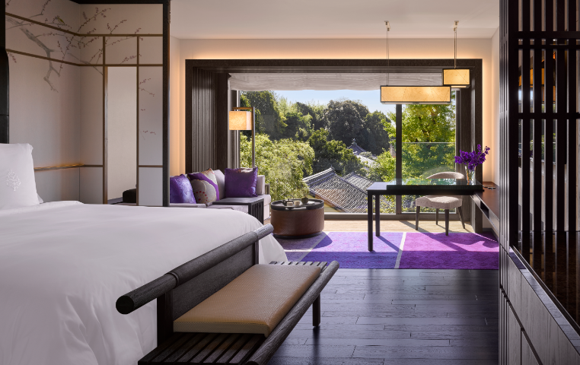
FOUR SEASONS KYOTO
Centered around Ikeniwa Pond and inspired by Kyoto’s Robust, picturesque seasons, HBA’s design pays homage to 800 years of heritage. The Four Seasons Kyoto features 110 standard rooms, 12 suites, one presidential suite and 57 condo unites. Designed to be a haven of quiet dignity and discreet expression, the Four Seasons Kyoto’s design narrative was carefully planned surrounding Ikeniwa Pond, inviting guests to engage with nature through its blueprint. A rich model of modernism resonates throughout the hotel while carefully maintain traditional Japanese conceptions of architecture.

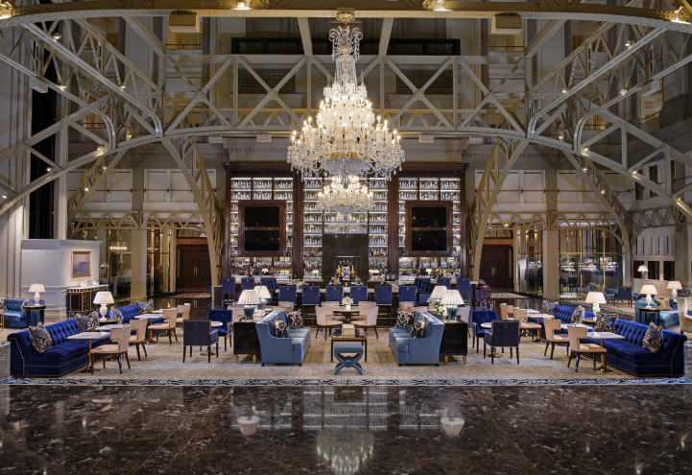
TRUMP INTERNATIONAL HOTEL, WASHINGTON, D.C.
The opening of the Trump International Hotel, Washington, D.C. signifies the most momentous historical hotel preservation project in the United States. Formerly the Old Post Office, the new hotel has been restored its original splendor as HBA meticulously worked to restore the building, creating a 263-room luxury five-star hotel and breathing new life into the property for a modern era.

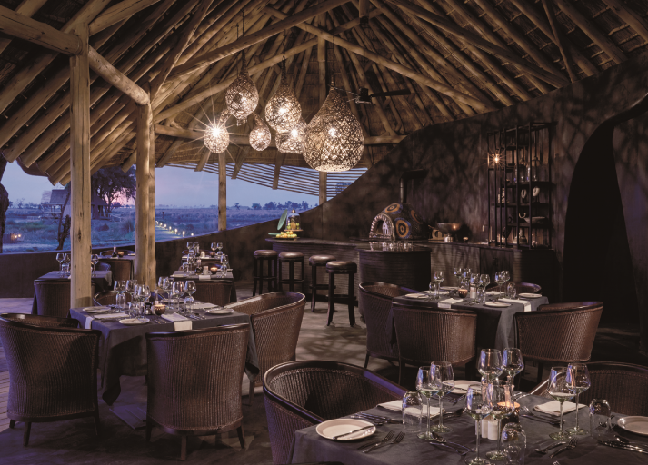
Eagle Island Botswana
Perched on a private island surrounded by some of the deepest stretches of the delta, Belmond Eagle Island Lodge encompasses 12 luxury tented guestrooms, each with a large terrace and plunge pool; a dining pavilion; a lounge pavilion across two levels; an arrivals boma; a retail area; the Fish Eagle Bar; a library and internet lounge; and a camp fire area. All the structures are new, their form inspired by the astonishing and massive ant nests which rise from the local landscape, as well as the gentle motion of the nearby water channels.
###
Media Contact:
Shelly Levin, Director of Public Relations
Hirsch Bedner Associates (HBA)
Shelly.Levin@HBA.com

