HIRSCH BEDNER ASSOCIATES (HBA) SETS NEW DESIGN STANDARD FOR INDIGO HOTELS WITH NEW FLAGSHIP HOTEL INDIGO LOS ANGELES DOWNTOWN; OPENS FEBRUARY 2017
HBA Blends Four Decades of LA’s History with Indigo’s Signature Graphic Style for
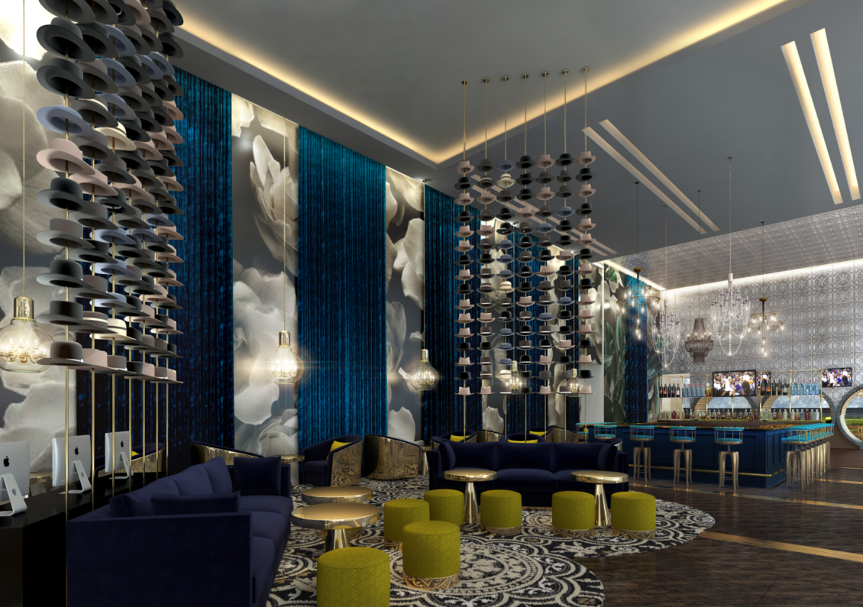
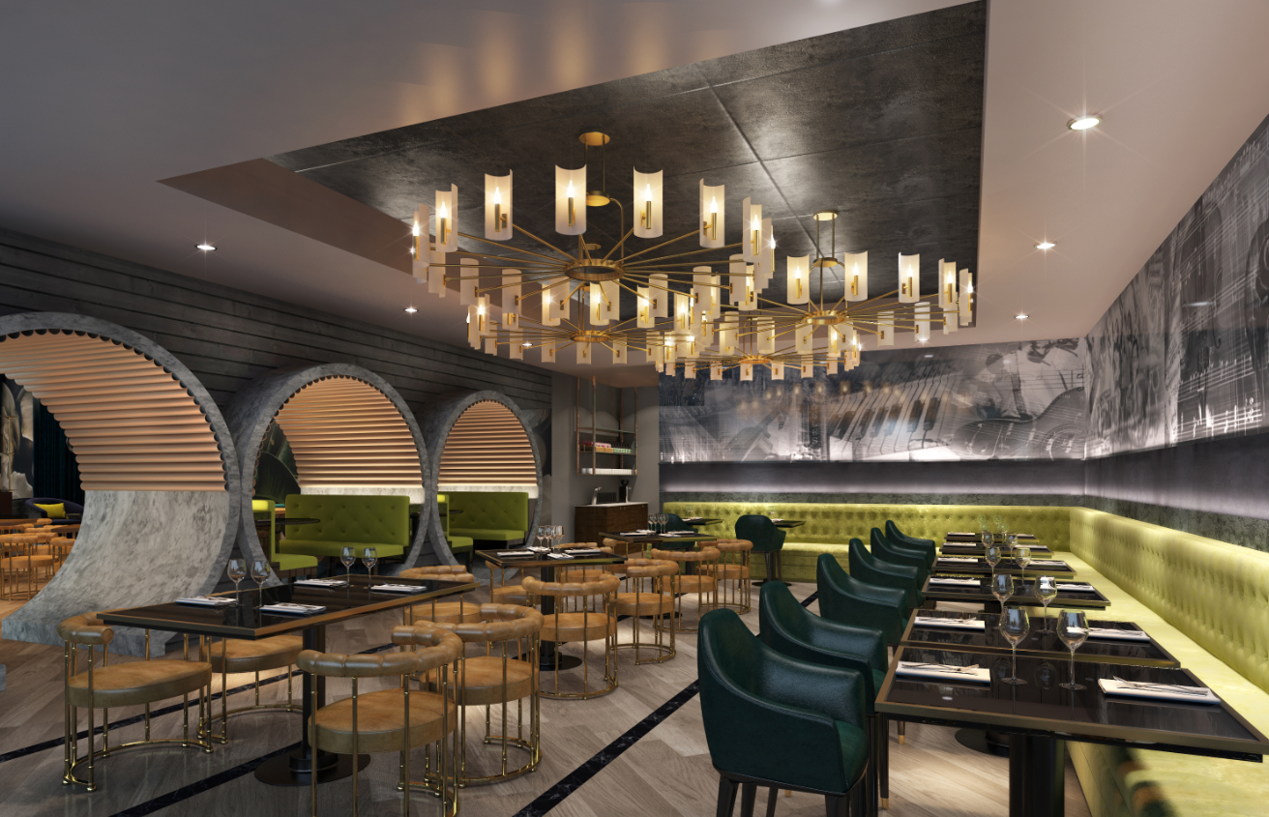
Downtown Metropolis Hotel
LOS ANGELES (December 1, 2016) – Hirsch Bedner Associates (HBA) the global leader in hospitality interior design, aims to captivate guests entering the new Hotel Indigo Los Angeles Downtown – one of the largest Indigo properties in the world – by taking inspiration from turn-of-the-century entertainment in the area. The 350-room property, set to open February 2017, is part of the larger Metropolis development in Downtown Los Angeles’ Historic Core, and entices guests upon arrival by the boldness and grandeur of the lobby, while showing a playful appeal through hints of downtown Los Angeles’ storied past.

Four stories from the late 1800s to the 1920s influenced HBA’s design for Hotel Indigo Los Angeles Downtown – The Fiesta de las Flores parade in the late 1800s, the budding movie industry and vaudeville glamour, underground tunnels and speakeasies of the 1920s, and the starlets and directors of the time. The hotel will infuse moments of each narrative with industrial undertones that speak to the direction that downtown is headed.

“Being involved in the hotel boom that is happening in Downtown Los Angeles is an incredible opportunity for our office – we were able to reinterpret Indigo’s brand story by infusing whispers of Downtown Los Angeles’ famed history,” said HBA Associate Richard Tennill. “In addition to being able to design a project in our own backyard, we’re able to create a look that is unique to LA’s past where visitors can discover and explore portions of the area’s history they have never before seen.”

The lobby, grand by design, will be an experiential progression through each of the four stories. The entrance to the Hotel Indigo Los Angeles Downtown tells the story of carriages, bicycles, buggies and other moving machinery decorated with multiple flowers and displayed for the crowds at the Fiestas de las Flores, which has now evolved into the Rose Parade. Large murals with ghosted flowers over imagery of the decorated carriages and crowds cover the walls of the lobby lounge. Above the reception desk, a custom chandelier by Illuminate composed of 30 large spokes hangs horizontally with light bulbs shinning down their center, illuminating the freestanding, floral-decorated "penny-farthing" bike set on display. Illuminate, HBA’s lighting consultancy designed vintage-style luminaires with industrial materials while using the latest LED technology to conserve energy. Architectural lighting is integrated into the building’s forms and interior details to emphasize the material and character of each space.

The lobby-level Metropolis Bar + Kitchen restaurant carries on the neighborhood’s story of 1920s secret tunnels and underground parties of the Prohibition era. The design splits its space into two by inserting seating and a passageway through concrete tunnels. The bar on one side of the tunnel is embellished with brass and copper metals reflecting on the 20-foot tall wall and ceiling cladded in pressed tin tiles. On the other side of the tunnels, a more intimate space with softer tones and a mural of jazz bands welcomes guests to a private event, an underground party reminiscent of a speakeasy during the time of Prohibition.

Influenced by the theaters in Downtown Los Angeles and envisioned to be a place where Angelenos would decompress while enjoying 1920s signature drinks and the extensive view, 18th Social is a lounge and bar space located on the 18th floor and was designed with the comfort of luscious blue velvets and a modern interpretation of the era’s design. Patterns were modernized and eclectically mixed. The space, all in a dark blue tone, will be accented by neon lighting and multiple metal finishes. The mixed seating arrangement, with different chair designs throughout, add to the uniqueness of this space and provides for private seating areas for each group of patrons. In addition to being welcomed by framed old photographs of the theaters lining Broadway, a giant worm’s eye view of an iconic theater was placed on the ceiling of the lounge to give the perspective of an extended ceiling height.

The guestrooms and suites were inspired by the movie starlets and famous directors of that period with a focus on Anna May Wong, who is considered the first Chinese American movie star. Both guestroom types are composed of mostly loose pieces of furniture to give rooms a residential fee and include a mural over the bed that imagines what the guest would have seen out their window during that time. These murals open up the space and introduce a view into the past. The first style of guestroom took inspiration from starlet Anna May Wong during her time living in Downtown Los Angeles and uses colors from the bougainvillea flower, which still grows in gardens throughout the city. For the executive guestrooms, the feel needed to be more masculine – the director – and uses tones of brown and maroon from leather and woods found in an office.

The meetings and convention space takes inspiration from the formalwear patterns and textiles of the early 1900s pre-Hollywood galas and used those fabrics to upholster seating and carpet the floor. Down the long corridor facing a glass façade, giant images of precious stones are displayed, which shine in contrast to the dark blue painted walls behind them. Upholstered walls and wood veneers line the corridors to the meeting spaces. Following Indigo’s signature style, a substantial mural on the fourth floor showcases two large murals portraying the energy of dancers at the galas in an oversized manner leading to the outdoors.

###

About Hirsch Bedner Associates (HBA)
World-renowned as the “Number One Hospitality Design Firm” by INTERIOR DESIGN, Hirsch Bedner Associates (HBA), HBA creates the signature looks of today’s luxury brands and unveils the world’s most anticipated hotels, resorts, spas, casinos, restaurants, cruise ships, independent contemporary boutique hotels and world-class residences. Leading the hotel design industry since 1965, HBA remains keenly attuned to the pulse of changing industry trends governed by today’s sophisticated traveler. The company′s international presence, depth of experience, and detailed industry knowledge enables them to identify interior design trends at their source, make definitive predictions about new directions and innovations, and influence design standards at a global level. HBA′s ultimate objective is to add value, raise standards and enhance the brand of a project’s owner and operator.

From continent to continent, each HBA interior is the result of a unique and sensitive response to location, architecture, and client vision. With more than 1,500 designers around the globe in 23 offices in nearly every major city, HBA is a true global company. HBA′s international presence, combined with its extensive knowledge of the interior design industry, has facilitated the ability to rewrite the language of design with each new project. In the past six years, the firm has launched six new design divisions, including Illuminate, Studio HBA, Canvas Art Consultants, HBA Architecture, HBA Graphics and HBA Residential.

In the past year, HBA has been honored by Hospitality Design's Platinum Circle Visionary Award and HD Awards, Boutique Design's Gold Key Awards, MEIDA 2017 Awards, China Starlight Awards, China Golden Pillow Awards, and Best D.E.S.I.G.N. Hotel Awards, to name a few. www.hba.com

About Hotel Indigo Los Angeles Downtown
As the new defining flagship for the Hotel Indigo brand, Hotel Indigo Los Angeles Downtown will be the brand’s entrée into the Los Angeles market and will be managed by world-renowned Intercontinental Hospitality Group, which currently has 5,000 hotels in its portfolio. With over 70 properties worldwide, Hotel Indigo is IHG’s boutique lifestyle brand that combines authentic local experiences, modern design, and intimate service with the peace of mind and consistency of staying with one of the world’s largest hotel groups.

Media Contacts for Hirsch Bedner Associates (HBA):
Shelly Levin
T. 310.586.2825
E. Shelly.Levin@hba.com

Media Contacts for Hotel Indigo Los Angeles Downtown:
The Brandman Agency
T. 323.944.0064
E. hotelindigoLA@brandmanpr.com

